New Business Rules import model
The problem:
The current configuration of all the Business Rules imports is uses the following classes
- Class CMBusinessRulesImportWizard
- Interface CMBRImporter and some implementors
- Enum ECMBusinessRulesImport
- Enum CMBRKeyword
- JPanel extensions
- WizardPanelDescriptor Extensions
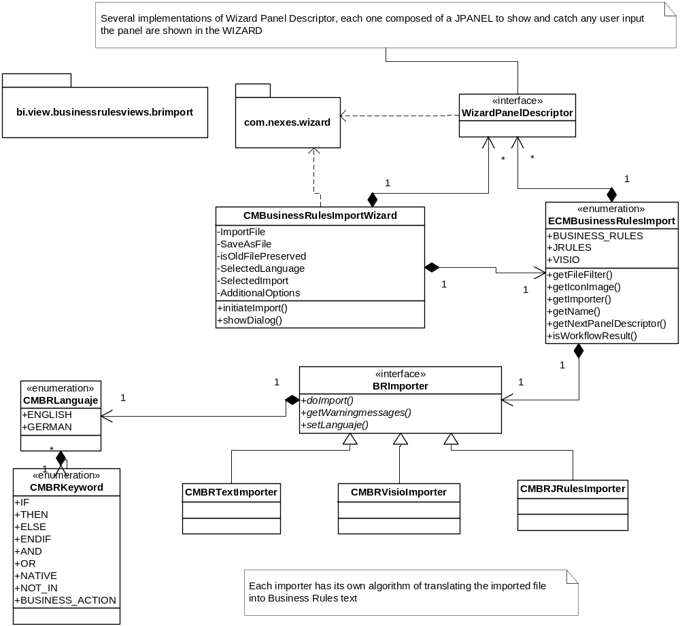
The BRImporter implementers that have the following responsibilities and tasks:
- Interpret the contents in the imported file to generate an import object model
- Match this new imported object model with Business Rules constructs
- Create a Syntactically correct Business rules text (including tabs and comments)

Interpret the contents in the imported file to generate an import object model
Since the imported sources can vary very much from one import to another, each imported format needs a standard import model. This can be done using external helper tools like XMLBeans (used by JRULES importer ) or XSLT transformations and Javacc (used by Visio import) so much of this work is actually delegated to many helper classes automatically generated by one of those tools
Match this new imported object model with Business Rules constructs
This class also have to reflect the mappings between the imported object model and Business Rules Constructs
Create a Syntactically correct Business rules text (including tabs and comments)
As the class interprets the imported object model also has to create a syntactically correct Business Rules text
In Conclusion:
If the imported source has too many options and too many constructs(like JRules) then this importer algorithm can became a heavyweight class (very hard to maintain)
Solution proposal
The initial refactoring includes taking away the responsibility to Create a Syntactically correct Business Rules Text into a new package/ subsystem
Because of the complexity of the JRULES language it’s necessary to create an independent Business Rules model that will contain the information of a Business Rules Text file but distributed in various objects:
What is the goal?
- Increase the flexibility in order to allow any change made to the current BR syntax will change only the adornments of each Business Rules model class
- Take some responsibility away from the import algorithm that has to deal with string concatenation and Syntax
- Help the to clear the mappings between Casemaker Business Rules and any foreign representation of Business Rules

